13th October 2023
Dear parents and carers,
Changes to Before and After School Clubs
As a result of increasing numbers of children attending our Before and After School Clubs and resulting issues with pupil: staff ratios, we are making a change to our current arrangements. From Monday, children must be booked into the Before and After Clubs – this will mean by 3.30 pm the previous day for the Before School Club and by 9.30 am on the required day for the After School Club. We are finding an increasing number of pupils arriving, particularly for the After School Club, who have not previously booked, and this is creating a potential safeguarding problem. It is no longer tenable for us to accommodate pupils who turn up on the day. Unless there is an emergency, please always book in advance.
In addition, from Monday we ask parents/carers to sign their children in on arrival at the Before School Club and sign them out when collecting them from After School Club.
The Before and After School Clubs are essential for our working parents and carers and we want to ensure that we continue to offer a good quality of care for their children. The most important part of this is making sure that our safeguarding arrangements are robust.
Thank you for your cooperation.
Yours faithfully,
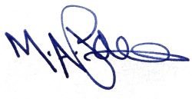
M Paine
Principal

